**ChartMD UI PROJECT**

**We have implemented what you provided and have run into some difficulties. Kindly see the following.**

**OLD LOG ON |** Please see the font size etc.

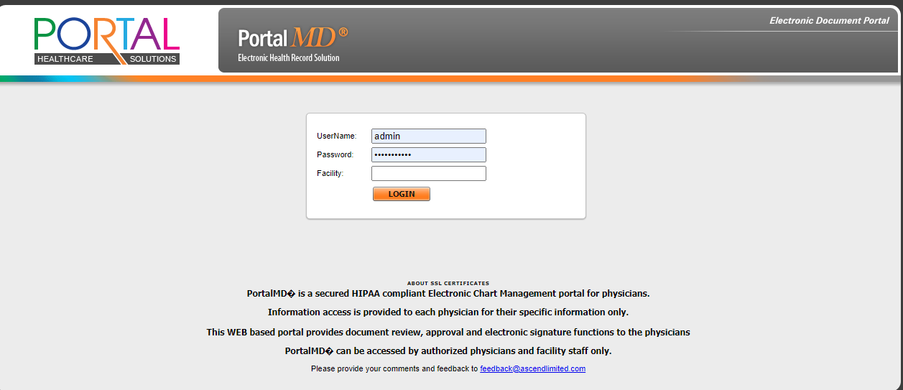

**NEW LOG ON |** Please see the FACILTY line. It should be gray not red.

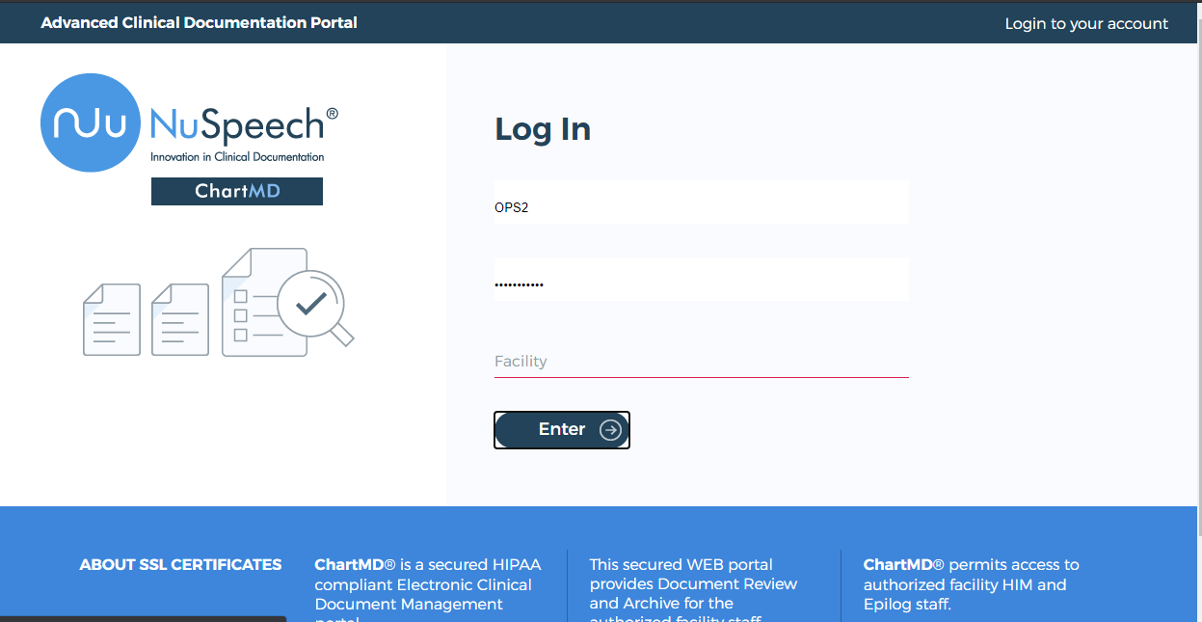

**OLD SEARCH PANEL AND RESULTS |** Please see the compressed size of SEARCH PANEL. This allows more display of results. We need 25 results displayed. This display is at 90% zoom.

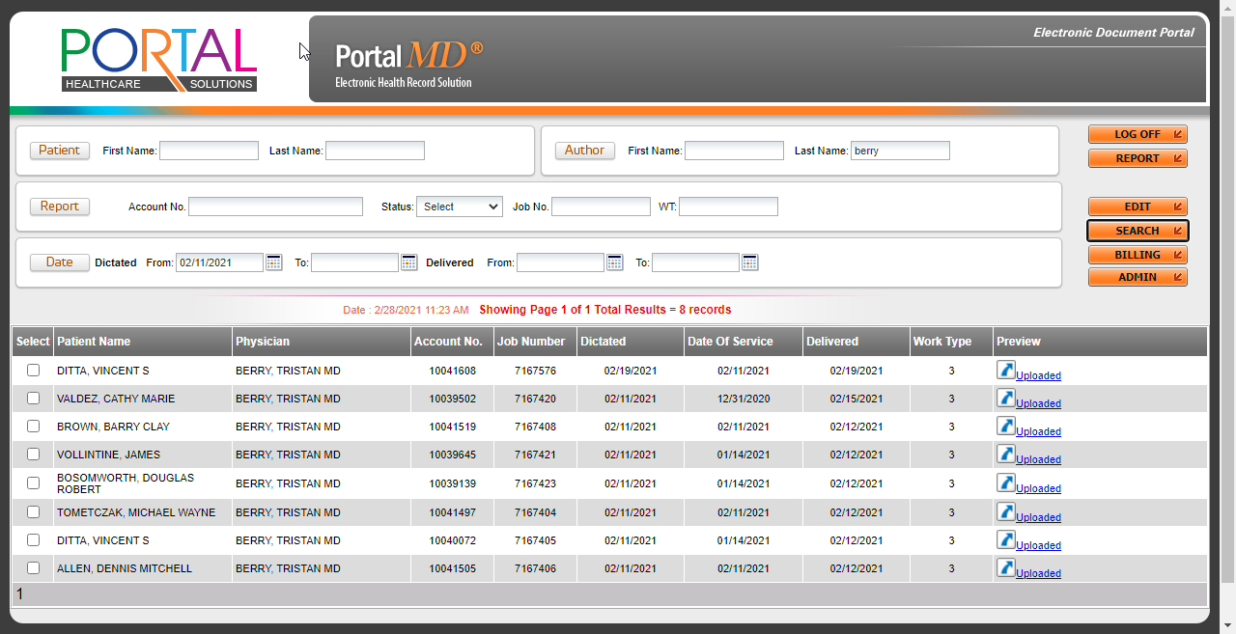

**NEW SEARCH PANEL AND RESULTS |** I have to reduce display to 25% to fit the page. We need to compress SEARCH PANEL almost 40%+ to allow more results to show. We also need to reduce the size of RAW height and create a smaller square check box on the left. The goal is to have SEARCH PANEL and 25 REPORT display should fit with 90% zoom. It does on OLD SKINS.

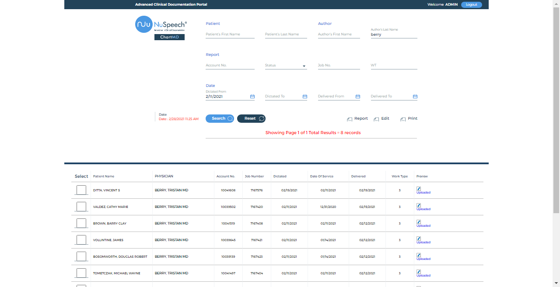

**NEW EDIT PAGE |** I missed asking for a new EDIT Page. Please provide packaging. This display is at 90% zoom.

